Concept Document for Consultation:

A Hearing Health Strategy for Aotearoa New Zealand

  - 8 APRIL 2026

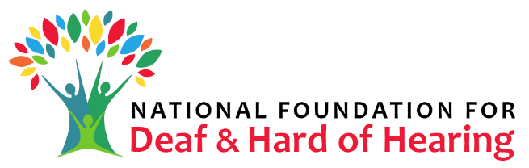
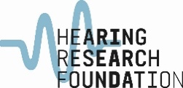

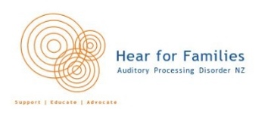
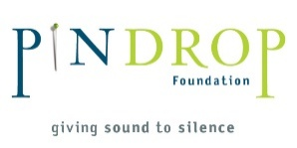
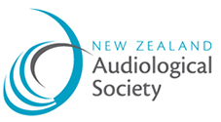

  - Contributing Member Organisations:
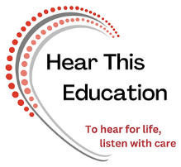

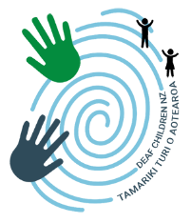


Executive Summary

Purpose
To establish Aotearoa NZ’s first national, co-designed strategy for hearing health, grounded in Te Tiriti o Waitangi, equity, prevention, and evidence-based practice.

Overall Aim
System change that ensures no person experiences preventable hearing loss, and that those with hearing conditions can live well, supported by equitable, culturally responsive prevention, care, rehabilitation, and technology. The ultimate vision is:
All people in Aotearoa NZ with hearing loss can achieve their full potential through access to services, rehabilitation, education and empowerment – delivered in culturally appropriate ways. No person experiences hearing loss due to preventable causes.

Why a Hearing Health Strategy is needed
- Hearing loss and related conditions affect around 18–19% of New Zealanders (≈880,000–1,000,000 people).
- Prevalence is rising due to ageing, unsafe listening behaviours, and unmet need.
- Impacts include reduced employment, productivity loss, depression, falls, cognitive decline, and social isolation.
- Māori and Pacific peoples experience a disproportionate burden due to inequitable access.
- Hearing loss imposes major economic costs; mitigation offers high returns on investment (hundreds of millions annually).

Scope
The strategy covers all people in Aotearoa NZ from a prevention perspective, and for those who have hearing loss or who are hard of hearing because of:
- Congenital hearing conditions
- Age-related or illness-related hearing loss
- Sudden or trauma-related hearing loss
- Progressive hearing conditions
- Associated conditions (tinnitus, hyperacusis, APD, etc.)

Foundations
The strategy is built on:
- Te Tiriti o Waitangi partnership, ensuring Māori-led design, delivery, and evaluation for Māori, by Māori
- Pacific-led approaches for Pacific communities
- Community-led co-design for all other cultural groups
- Enabling Good Lives principles
- United Nations Declaration on the Rights of Indigenous Peoples
- United Nations Convention on the Rights of Persons with Disabilities
- Continuous Quality Improvement (CQI)
- WHO’s Hearing Health Report (2021) including the Integrated People/Whānau-Centred Ear and Hearing Care (IPCEHC) model
- New Zealand national strategies relating to public health, hauora Māori, Pacific and Disabled wellbeing, and health services delivery.

Strategic Approach
- Adopt and adapt the WHO’s H.E.A.R.I.N.G. intervention package to the Aotearoa NZ context.
- Engage a cultural advisor as the strategy is developed to ensure we work in partnership under Tiriti o Waitangi.
- Collaborate across sectors – community, NGOs, government, clinicians, academia, and business.
- Commission services and programmes via a proposed new governance body (Hearing Health Alliance, who will commission programmes and projects based on the strategy).
- Embed continuous quality improvement across all activities.
- Elevate hearing health as a public health priority.

Key Components: The H.E.A.R.I.N.G. Framework
Adapted for Aotearoa NZ, covering:
- H: Hearing screening & early intervention (newborns to older adults; workers; prisons, etc.)
- E: Ear condition prevention & management.
- A: Access to hearing and assistive technologies.
- R: Rehabilitation services, including multidisciplinary, whānau-centred, and aural rehabilitation.
- I: Improved communication (NZSL, captioning, accessible public alerts/signage).
- N: Noise reduction (safe listening standards, occupational programmes, venue regulations, behaviour change, acoustics).
- G: Greater community engagement and public health promotion (multi-channel public health campaigns stigma reduction; strengthening organisations).

Governance: The Hearing Health Alliance
A new, independent entity that will:
- Set priorities
- Commission programmes and projects
- Oversee accountability and evaluation for the delivery of programmes and projects
- Report to funders and (where relevant) WHO
- Ensure Te Tiriti partnership, lived experience leadership, equity, and quality

Outputs
- A National Hearing Health Plan
- Commissioned, culturally appropriate programmes
- Expanded screening and technology access
- Scaled rehabilitation and communication support
- Public health campaigns
- National Continuous Quality Improvement metrics and dashboards

Outcomes

Short term (1–2 years)
- Funding and establishment of the Hearing Health Alliance via central Government
- Increased screening and technology uptake
- Improved public awareness and prevention behaviours

Medium term (3–5 years)
- Reduced unmet need (especially 65+)
- Improved Māori and Pacific equity
- Measurable productivity gains
- Safer listening environments

Long term (to 2030+)
- Decline in preventable hearing loss
- Hearing health embedded as a public health priority
- Sustained social and economic benefits

Economic Case (NZIER Findings 2023)
- $718–$924m gain in GDP per year from productivity improvements
- $408–$527m increase in household spending
- $1.26–$1.63b rise in industry output
- $478–$956m reduction in employment gap

Key Objectives
- Establish the national strategy with sector-wide support
- Embed a Kaupapa Māori foundation
- Secure funding for implementation
- Establish the Hearing Health Alliance
- Begin priority setting and commissioning co-designed programmes and projects
- Integrate hearing health into national public health priorities

Implementation Phases
- Finalise content for the draft strategy (V2) as the basis for community and sector consultation
- Launch consultation page and prepare business case
- Establish the Hearing Health Alliance
- Prioritise programmes and projects, establish Continuous Quality Improvement systems
- Launch strategy (aiming for World Hearing Day, March 3) and publish annual reports

Evaluation
External, independent evaluation of this Strategy and functional effectiveness of the Hearing Health Alliance at:
- 2 years
- 5-year intervals
- Criteria to include effectiveness, equity, efficiency, impact, sustainability, and evidence base.

